# Fake Review Detection

This involves automatically identifying and flagging fake or misleading reviews posted online. These reviews may be fabricated by individuals or generated by bots with the intention to manipulate consumer opinions.

**Dataset:**

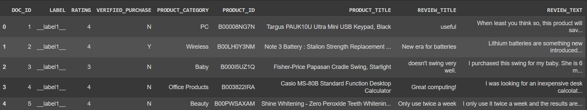

**Features:**

[DOC_ID, RATING, VERIFIED_PURCHASE, PRODUCT_CATEGORY, PRODUCT_ID, PRODUCT_TITLE, REVIEW_TITLE, REVIEW_TEXT]

**Target:**

LABEL:

__label1__ -fake

__label2__ - real

## Preprocessing Data Set

* Removed unnecessary features like IDs.
* Handling missing values: There are no missing values.

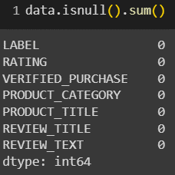

* Class imbalance: There is no class imbalance.

* Separated the dataset into 2 parts

1. **data_meta**: consists of features that represent the metadata of review

[RATING VERIFIED_PURCHASE PRODUCT_CATEGORY]

1. **data_text**: consists of features that are actually review text

[PRODUCT_TITLE REVIEW_TITLE REVIEW_TEXT]

### Preprocessing data_meta:

1. **Label Encoding:**

Rating, Verified_purchase features have inherent order among the categories. So, used LabelEncoder to encode them and also target LABEL into numerical values each value represents each category respectively.

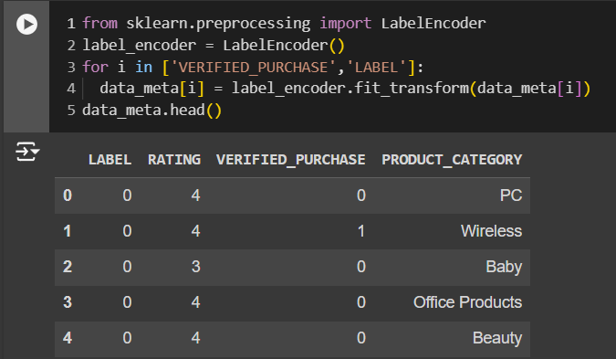

1. **One Hot Encoding for Product_category:**

Since there is no inherent order among values of product category one hot encoding is performed.

1. **Feature Construction:**

Constructed features like

'review_length', 'title_length', 'num_words', 'num_sentences',

'avg_word_length', 'num_unique_words', 'num_stop_words',

'punctuation_count', 'num_capitalized_words', 'sentiment_score',

'review_length_x_rating', 'verified_purchase_x_rating'.

1. **Scaling using Standard Scaler**

### PreProcessing data_text:

Conversion all letters to lower case, removal of stop words, removal of punctuation.

## Application of ML Models:

1. Tokenized the data_text using Tokenizer of tensorflow and concatenated both data_meta and data_text to apply following ml models

|  |  |
| --- | --- |
| Model | Accuracy |
| Logistic Regression | 0.7892857142857143 |
| Random Forest | 0.8161904761904762 |
| Gradient Boost | 0.8102380952380952 |
| LSTM | 0.8515, val_accuracy: 0.7621, loss: 0.3236, val_loss: 0.4933 |

1. Instead of combining giving PRODUCT_TITLE, REVIEW_TITLE, REVIEW_TEXT to a single LSTM created a LSTM layer for each and a network of Dense layers is used for training data_meta. This improved accuracy further to 0.8806 and decreased loss to 0.3222 and validation accuracy to 0.8260 and validation loss to 0.4862.
2. Then Implemented BERT embeddings instead of LSTM and other boosting techniques.

|  |  |
| --- | --- |
| Model | Accuracy Metric |
| BERT + Adaboost | 0.8088 |
| BERT + XGBOOST | 0.8283 |

## Hyper parameter Tuning:

GridSearch CV for searching best parameters for XGBoost model this lead to increase the accuracy of classification model to 0.8607.

## Gradio for Demo UI:

Employed Gradio package to deploy ui for testing the model.

## Future work:

Creation of web application for actual User Interface.

Frontend: React JS.

Backend: FLASK.